Megaplex predicting revenue Automl

Executive Summary
Megaplex Theatres engaged this analysis to understand what drives box-office performance and to forecast revenue for upcoming releases. Using the Movie_regression (1).csv dataset and an AutoML approach, we identified a Stacked Ensemble model that reliably predicts earnings and highlights the factors most strongly associated with financial success, particularly Budget, Trailer_views, and Multiplex coverage. The model’s accuracy provides a practical foundation for evaluating expected performance across new films and comparing the impact of different marketing, production, and distribution strategies. By integrating this predictive capability into pre-release planning, Megaplex can better allocate promotional resources, anticipate film performance, and make more confident acquisition and scheducling decisions that improve overall revenue outcomes.

Business Objective
Megaplex Theatres seeks to understand which factors most strongly drive box-office revenue and how these drivers can be used to reliably forecast earnings for unreleased films. Using the Movie_regression (1).csv dataset, the objective is to quantify the impact of marketing, production decisions, talent ratings, viewer engagement, and genre-specific attributes on total collections. The goal is to translate these insights into a predictive model capable of estimating revenue prior to release, enabling more accurate budgeting, scheduling, and promotional planning. Ultimately, this analysis supports data-driven decision-making around film acquisition, resource allocation, and promotional investment.

Data Science Task
To translate Megaplex’s business objective into a technical workflow, we framed the problem as a supervised regression task focused on predicting total box-office collections. Rather than committing to any single algorithm a priori, we employed an AutoML strategy through the H2O AutoML framework, allowing a broad set of models—such as Gradient Boosting Machines, Random Forests, XGBoost variants, and stacked ensembles—to compete for best performance under a consistent evaluation protocol. This approach ensures that model selection is driven by empirical performance rather than assumptions, while also highlighting which features consistently emerge as high-value predictors across candidate models. Later sections of the report detail which model ultimately proved most accurate and how its characteristics inform Megaplex’s strategic decision-making.

Data
The analysis uses the Movie_regression (1).csv dataset containing 506 films and 18 variables covering marketing spend, production choices, talent ratings, viewer engagement metrics, and categorical attributes (Genre, 3D_available). The target variable is Collection. Nearly all fields are complete, with only Time_taken showing limited missing values (12 records). Aside from the two categorical variables, all features are numeric, making the dataset well-structured for regression and AutoML modeling.

Data Exploration
Movie revenue shows a wide but unimodal distribution centered around the $35K–$50K range, with a long right tail driven by higher-performing films. 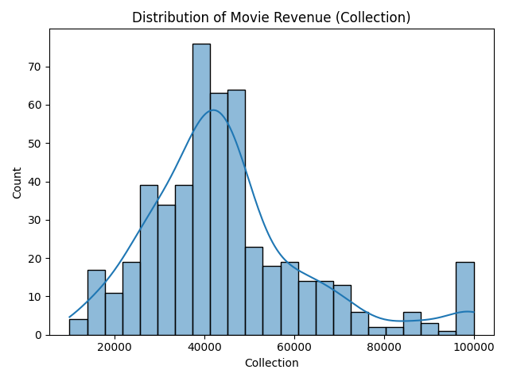
This spread indicates meaningful variance for the model to explain and supports the use of regression methods.
Budget displays the clearest positive linear relationship with revenue, forming a tight upward pattern that suggests production investment is one of the strongest revenue drivers.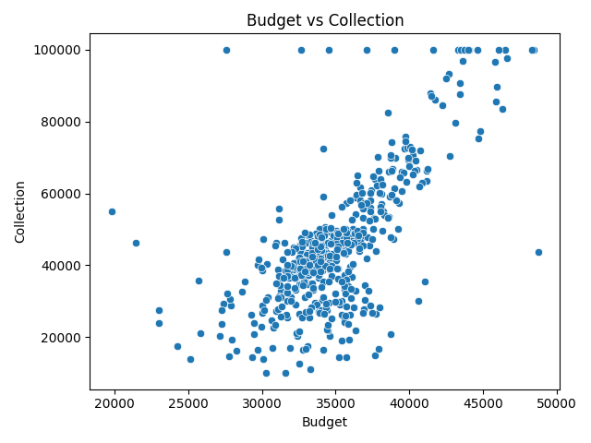
Trailer views also exhibit a well-structured distribution and appear positively associated with revenue, reinforcing the role of audience engagement prior to release.
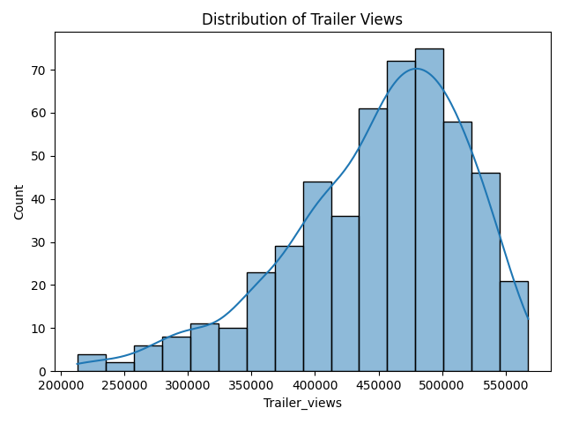
Among categorical features, films released in 3D consistently earn more on average than non-3D releases, with median revenue and upper-end performance both higher for 3D titles.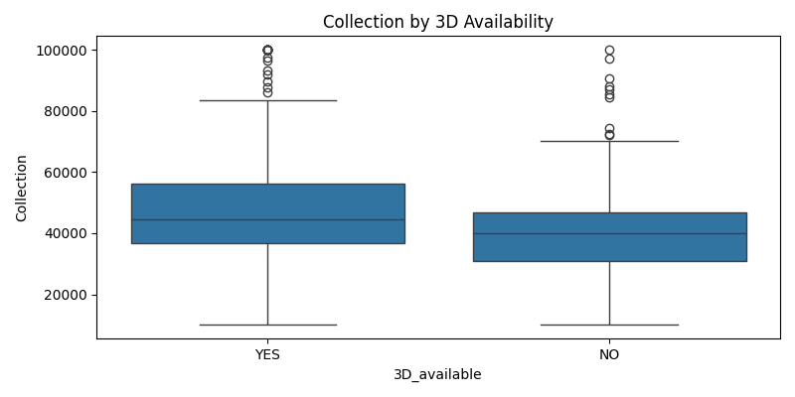
These patterns collectively confirm that production spend, marketing reach, and format decisions meaningfully influence financial outcomes and should be retained in downstream modeling.

Data Analysis
The visual diagnostics in this section support both the selection and the validation of the Stacked Ensemble model produced by AutoML.
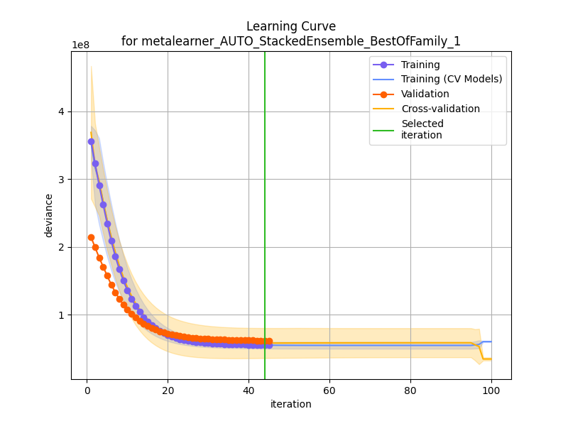
This figure shows how the ensemble’s error steadily decreases and plateaus as the number of iterations increases, indicating that the model reaches an optimal balance between underfitting and overfitting. This confirms that the ensemble had sufficient training capacity to capture the main revenue-driving relationships without degrading performance on unseen data.
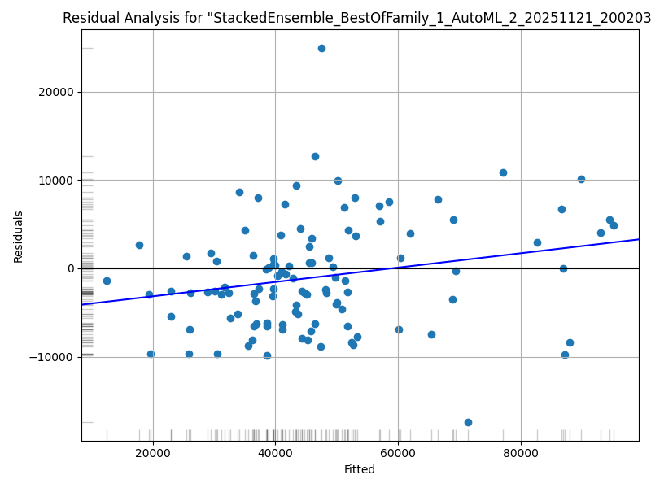
This image provides insight into model calibration by plotting fitted values against residuals. The absence of strong curvature or funnel-shaped patterns suggests that the ensemble does not suffer from major structural bias or systematic prediction errors. Residuals remain centered around zero across the revenue range, reinforcing that the model generalizes well to films of varying budget and popularity levels.
To understand which variables contributed most to predictive accuracy, reports the importance scores for one of the strongest gradient boosting models in the AutoML pool.
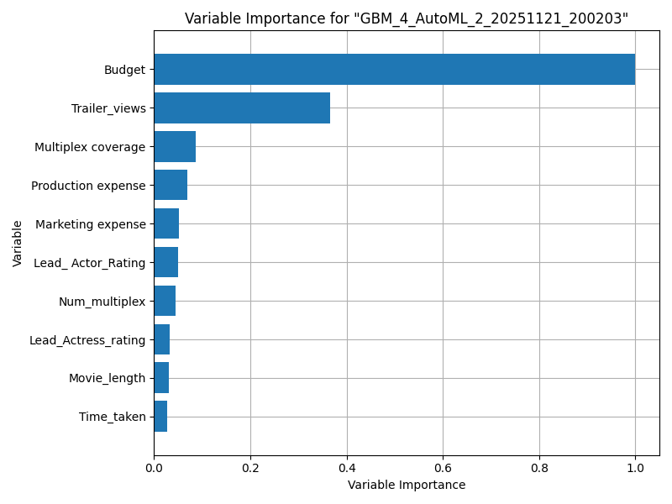
This plot highlights Budget, Trailer_views, and Multiplex coverage as the primary drivers of model performance. To validate that these drivers are not model-specific artifacts, 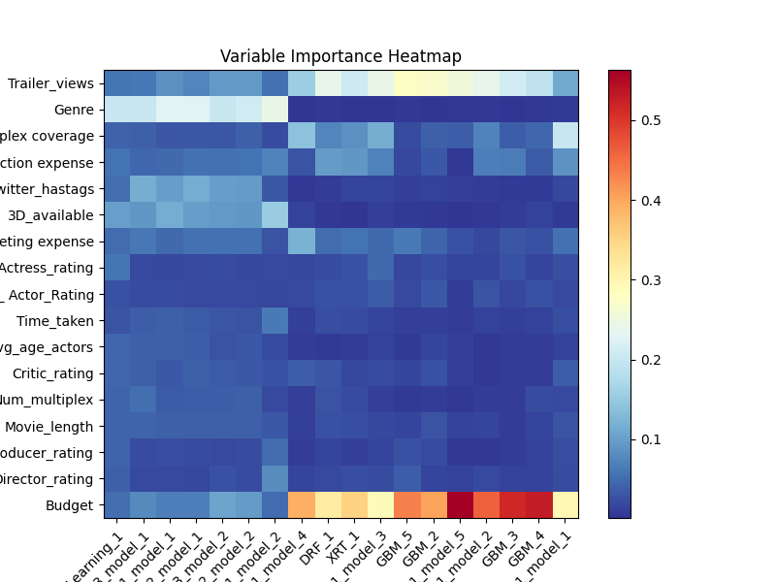this heatmap summarizes variable importance across all major AutoML models. The consistent emphasis on production investment and pre-release audience engagement across algorithms strengthens the conclusion that these factors materially influence movie revenue and should be prioritized in forecasting and planning decisions.

Apply Analysis
To demonstrate how the model can be used operationally, we applied the Stacked Ensemble to a new, hypothetical film profile reflecting realistic pre-release conditions. The input scenario represents a mid-budget film with moderate marketing activity (500 units), strong pre-release trailer engagement (~459K views), and wide distribution across 480 multiplex locations. When processed through the model, this profile yields a predicted box-office Collection of approximately $91,509.
Marketing expense | Production expense | Multiplex coverage | Trailer_views | Time_taken | Twitter_hashtags | Genre | Avg_age_actors | Num_multiplex | Predicted Collection
500.0 | 250.0 | 7.5 | 459241.0 | 157.39 | 260.83 | Drama | 35 | 480 | 91,509.03
This example illustrates how Megaplex can use the model to evaluate expected performance under different marketing, production, and distribution strategies. By adjusting inputs such as budget, marketing spend, or trailer reach, decision-makers can simulate revenue outcomes and compare the projected ROI of competing promotional or scheduling options. This makes the model not only a forecasting tool, but also a practical instrument for scenario planning across upcoming film releases.

Deploy Model
The final Stacked Ensemble model was exported from H2O and saved as a production-ready artifact, enabling Megaplex to reuse the model without retraining. With the saved model file in place, new movie profiles can be scored immediately by loading the model object and supplying the relevant film attributes—such as marketing spend, trailer engagement, genre, and distribution footprint. This enables Megaplex to generate revenue forecasts on demand for upcoming releases and evaluate multiple promotional or scheduling strategies before committing resources.
Operationally, the model can be integrated into Megaplex’s forecasting workflow by embedding it into a lightweight Python script or dashboard where analysts input film parameters and retrieve predicted earnings. This allows the organization to support acquisition decisions, optimize marketing allocations, and simulate alternative release plans using a consistent, data-driven framework.

Assess Results
The Stacked Ensemble model performs well on unseen data, reaching an RMSE of ~$6.24K and an R² of ~0.898, meaning it explains most of the variation in movie revenue and generally predicts within a reasonable margin for planning purposes. Given the wide revenue range in the dataset, this accuracy is strong enough to support decisions around budgeting, scheduling, and marketing strategy without requiring exact dollar-level precision.
The model consistently highlights Budget, Trailer_views, and Multiplex coverage as the main revenue drivers, reinforcing the patterns observed in the exploratory analysis and validating the model’s relevance to real-world theater operations. Although improvements are possible with additional data, the current model is reliable for forecasting and comparing expected performance across new releases.

Method Strengths and Weaknesses
Strengths:
The AutoML approach provided a rigorous, unbiased way to compare a wide range of algorithms under consistent evaluation criteria. This ensured that model selection was driven by actual performance rather than subjective preference and allowed Megaplex to benefit from an ensemble model that captures nonlinear relationships and interactions that simpler models may miss. AutoML also streamlined preprocessing, validation, and hyperparameter tuning, giving the organization a high-performing model with minimal manual intervention.
Weaknesses:
Because the ensemble blends multiple complex models, its internal logic is less transparent than a single interpretable model, limiting its usefulness for situations requiring detailed causal explanations. The approach is also constrained by the quality and scope of the dataset; important factors such as release timing, franchise effects, or regional competition are not captured, which may cap the model’s ceiling of accuracy. Finally, deployment requires ensuring compatible software environments and may not be as lightweight as using a simpler, standalone model.

Appendix
- H2o Practice Asg.ipynb — instructor reference file
- Movie_regression (1).csv — dataset used in the analysis
- movie_regression_h2o_pipeline.py — final Python script
- ChatGPT — used for written interpretation and report structuring

